Use Case Realisation Report (Analysis) - Post Feedback FOR
Volunteer Management System
(VMS)

CLIENT
PROJECT | Volunteer Management System (VMS)
TITLE | Use Case Realisation Report (Analysis) - Post Feedback
VERSION | 0.3a0.2a
DATE | 13-Aug-2011
 | ORIGINATOR
 | Name / Signature | Team 8S
 | APPROVAL
 | Name / Signature | Phung Kim Cuong, Dio
Institute of Systems Science |  | Document Reference
25 Heng Mui Keng Terrence  Singapore 119615 |  | VMS/T-1.4.1/1

 | Acceptance
 | Customer Signature |  | Customer Signature
 | Name & Designation |  | Name & Designation
 | Date & Company Stamp |  | Date & Company Stamp

Revision History

Date | Version | Description | Author
12-Jun-2011 | 0.1a | Creation | Team 8S
11-Aug-2011 | 0.2a | Updates | Team 8S
12-Aug-2011 | 0.3a | Updates | Team 8S

Table of Contents

1. Brief Description 3
2. Flow of Events 3
2.1 Standard Flow 3
2.2 Exceptions 3
3. Interaction Diagrams 4
3.1 Domain Collaboration Diagram: Post Feedback 4
4. Participating Objects 4
4.1 Volunteer 4
4.2 UserFeedback 4
4.3 Document 4
4.4 ProjectDetailsScreen 4
4.5 UserFeedbackScreen 4
4.6 ProjectController 4
5. Class Diagram 5
6. Derived Requirements 5
ANNEX D Amendment History 5

Use Case Realisation Report (Analysis) - Post Feedback

Brief Description
The use case enables registered user to propose new project.

Flow of Events
The standard flow of events for this use case and any exceptions are described in the following subsections. See section 3.1 for an overview of the participating Actors and Domain Objects.

Standard Flow

Precondition: Volunteer has logged in the system and use case 4.6 has been executed
This use case provides the user interface related functionality that will be provided to the User, as follows:
- When Volunteer clicks ‘Post Feedback’ button on the ProjectDeatilsScreen, the ProjectDetailsScreen.postFeedback() method is triggered.
- ProjectDeatilsScreen uses the method ProjectController.redirectURL() to display the UserFeedbackScreen to Volunteer.
- ProjectController.redirectURL() will use UserFeedbackScreen.show() method to show a new input form to Volunteer.
- Volunteer can also enter the text in the form. Volunteer can also upload supporting document or attach images using UserFeedbackScreen.uploadDocumnet().
- When Volunteer click ‘Submit’ button, UserFeedbackScreen.onSubmit() will be triggered and it will use the ProjectController.saveFeedback() method to save the user input information to data persistence.
- ProjectController will create a new UserFeedback object with user input info by using UserFeedback.create() and save to data persistence layer.
- ProjectController will create one or more Document objects to save user uploaded docs or images.
- ProjectController will use UserFeedbackScreen.displayMsg() to display a confirmation message to the volunteer.
- The use case terminates.

Exceptions
The following exceptions have been identified:

Interaction Diagrams

Domain Collaboration Diagram: Post Feedback
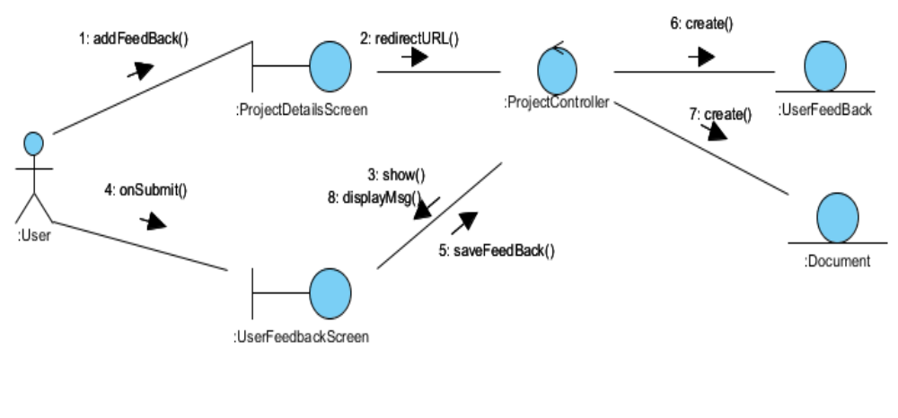
Figure 1 - Collaboration Diagram

Participating Objects

Volunteer
This entity object stores the details concerning a volunteer of the volunteer organisation. The primary attribute that it holds is the userID.

UserFeedback
This entity object stores the details concerning a user feedback that volunteer created. The primary attribute that it holds is the userStoryID.

Document
This entity object stores the details concerning a document that volunteer uploaded. The primary attribute that it holds is the docID.

ProjectDetailsScreen
This boundary object is used for collection of project details. User actor uses this object.

UserFeedbackScreen
This boundary object is used for collection of feed back. The Volunteer actor uses this object.

ProjectController
This control object co-ordinates the creation, update, viewing and searching project record in the volunteer management system. It receives requests from the boundary objects allocated for the specific purposes, along with all the necessary details required for the execution of these requests.

Class Diagram
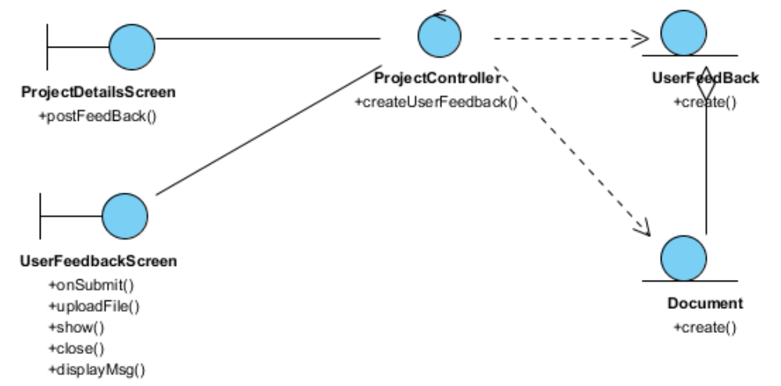
Figure 3 - Class Diagram

Derived Requirements

ANNEX D Amendment History
This is a record of all amendments made to the Document.
Version | Chapter / Section | Page No | Notes of Amendments or Changes

